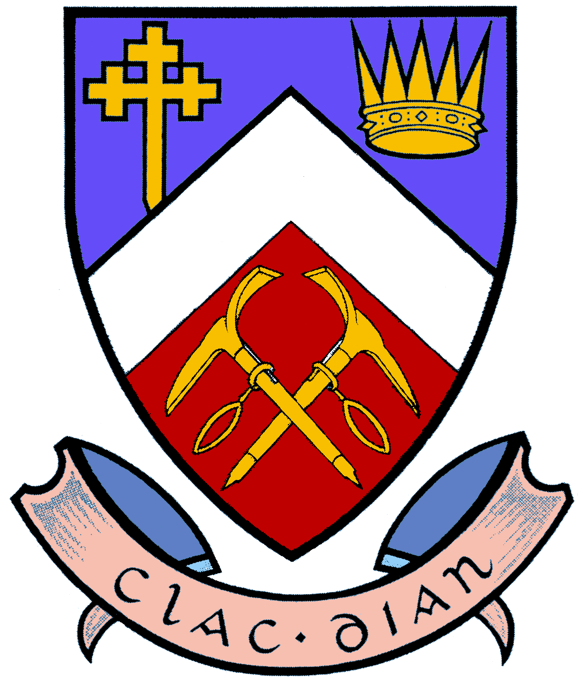
THE CAIRNGORM CLUB
Membership Application Form
The Cairngorm Club and Mountaineering Scotland recognise that climbing and mountaineering are activities with risks of personal injury or death. Participants in these activities should be aware of and accept these risks, and be responsible for their own actions and involvement. Members and others participate in Club activities at their own risk; the Club accepts no liability.
Please read the “Club Membership” page at www.cairngormclub.org.uk
Club subscriptions include Mountaineering Scotland membership and civil liability insurance. Current rates are available on the Club website.
Title (Mr, Mrs, etc.) _____ Name (block capitals) _____________________________________
Address _____________________________________________________________________
____________________________________________________ Post Code ______________
Telephone _________________ (home) ________________ (work) ________________ (mob)
E-Mail _________________________________________________________________
Membership Type
Ordinary (see over) | Associate | Interim (6 months)
I have existing Mountaineering Scotland membership
If yes, please state your MS membership number or other affiliated club: -
Reduced Rate
65 or over | 21 or under  Date of birth: .................…. | in full-time education  until: ….........................
Living and working over 80km from Aberdeen

How did you hear about the Club?

Data Protection
The Cairngorm Club takes your privacy seriously and we only use your personal information to administer your membership. We register you with Mountaineering Scotland, which uses your personal data to provide you with access to its membership services and benefits. Please read privacy notices for the Club (www.cairngormclub.org.uk/membership/PrivacyNotice.pdf) and Mountaineering Scotland (www.mountaineering.scot/privacy-notice) which set out how your data, is used, who we share it with, how we keep it secure and your rights as a data subject.

Your Signature ____________________________________ Date _____________
Please send this form to the Membership Secretary who will acknowledge receipt and let you know the initial subscription payable.
ORDINARY MEMBERSHIP (ONLY) Name:
The Committee grants Ordinary Membership to those whom it considers to be able, in general terms, to look after themselves and to lead one or two others in all conditions normally encountered on the Scottish hills, though without expecting any proficiency in skills requiring the use of ropes. This level of ability will generally be inferred from experience amounting to at least thirty Munros, including at least four in the Cairngorms, and at least ten in winter conditions; but non-Scottish experience will also be recognised. Please summarise your experience below listing winter experience first. Add additional sheets if needed.
Date  (year, season) | Mountain(s) | Ground (or Cliff) Conditions | Overhead Conditions
Please ask two Ordinary members to propose and second your application by signing below.
 | Signature | Name (block capitals)
Proposer | __________________________ | _____________________
Seconder | __________________________ | _____________________

